**MySQL – DDL Command demonstrate**

Write SQL code to create **ddl_demo** database and create below table with proper datatypes and constraints.

Table : student

|  |  |  |  |  |  |  |  |
| --- | --- | --- | --- | --- | --- | --- | --- |
| **USN** | **NAME** | **DOB** | **ADDRESS** | **CITY** | **STATE** | **PINCODE** | **CGPA** |
| 1SI23MBA01 | AAA | 1995-01-01 | B H ROAD | TUMKUR | KARNATAKA | 572103 | 8.5 |
| 1SI23MBA02 | BBB | 1996-01-01 | BANGALORE | BANGALORE | KARNATAKA | 560001 | 9.5 |
| 1SI23MBA03 | CCC | 1997-01-01 | M G ROAD | TUMKUR | KARNATAKA | 572103 | 7.5 |
| 1SI23MBA04 | DDD | 1998-01-01 | B H ROAD | TUMKUR | KARNATAKA | 572103 | 8.5 |
| **1SI23MBA04** | **DDD** | **1998-01-01** | **B H ROAD** | **TUMKUR** | **KARNATAKA** | **572103** | **8.5** |
| **1SI23MBA05** |  | **1999-01-01** | **B H ROAD** | **TUMKUR** | **KARNATAKA** | **572103** | **8.5** |
| **1SI23MBA06** | **FFF** | **1999-01-01** | **B H ROAD** |  |  |  |  |

Write SQL statements for following questions:

1. Create new database name **ddl_demo**
2. List all the database available in MySQL
3. Select **ddl_demo** database to execute DDL statement
4. List all the tables available in **ddl_demo** database
5. Create student tables with proper datatypes and constraints on columns
   1. USN must be always unique and not allow to enter NULL values, apply PRIMARY KEY constraint on USN
   2. NAME must have values always, apply NOT NULL constraint on NAME
   3. CITY, STATE, PINCODE, CGPA should have default values TUMKUR, KARNATAKA, 572103, 0 respectively.
6. List all the table available in **ddl_demo** database
7. View the student table structure
8. Insert above given data for student table.

* Red highlighted records demonstrate Primary Key constraint, show error while inserting duplicate records.
* Blue highlighted records (1SI23MBA05) demonstrate NOT NULL constraint on Name column.
* Green highlighted records (1SI23MBA06) demonstrate DEFAULT constraint on CITY, STATE, PINCODE, CGPA columns

1. Execute the TRUNCATE command to delete all the records from student table
2. Drop student table from **ddl_demo** database.
3. List all the tables after dropping student table.
4. Drop **ddl_demo** database from MySQL.
5. List all the database after dropping **ddl_demo** command.

**SQL Codes:**

1. Create new database name **ddl_demo**

**CREATE DATABASE ddl_demo;**

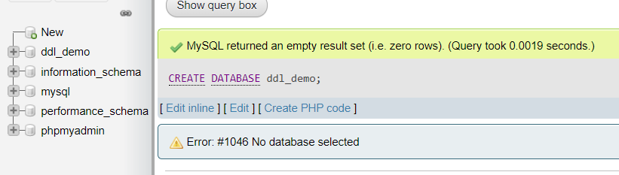

1. List all the database available in MySQL

**SHOW DATABASES;**

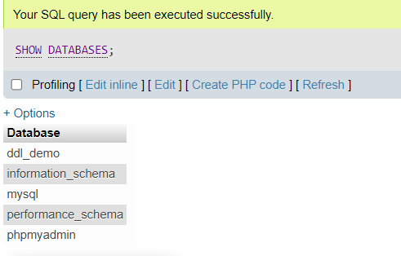

1. Select **ddl_demo** database to execute DDL statement

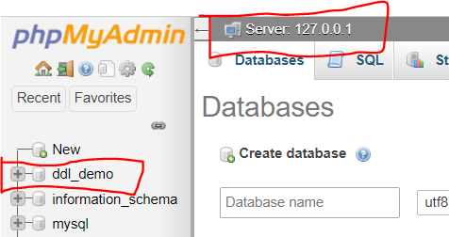

Click on **ddl_demo** to select it, once it gets selected database name get display with Server details.

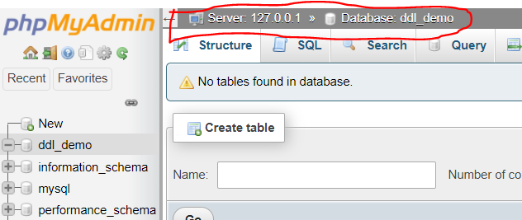

1. List all the tables available in **ddl_demo** database

**SHOW TABLES;**

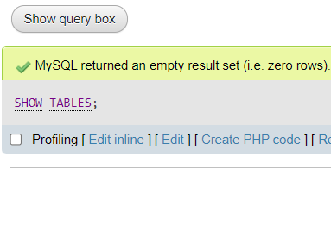

Since there are no tables in ddl_demo, show tables command giving empty result set.

1. Create student tables with proper datatypes and constraints on columns
   1. USN must be always unique and not allow to enter NULL values, apply PRIMARY KEY constraint on USN
   2. NAME must have values always, apply NOT NULL constraint on NAME
   3. CITY, STATE, PINCODE, CGPA should have default values TUMKUR, KARNATAKA, 572103, 0 respectively.

**CREATE TABLE student(**

**USN CHAR(10) PRIMARY KEY,**

**NAME VARCHAR(20) NOT NULL,**

**DOB DATE,**

**ADDRESS TEXT,**

**CITY VARCHAR(20) DEFAULT 'TUMKUR',**

**STATE VARCHAR(20) DEFAULT 'KARNATAKA',**

**PINCODE INT DEFAULT 572103,**

**CGPA FLOAT DEFAULT 0**

**);**

1. List all the table available in **ddl_demo** database

**SHOW TABLES;**

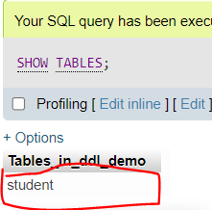

1. View the student table structure

**DESC student;**

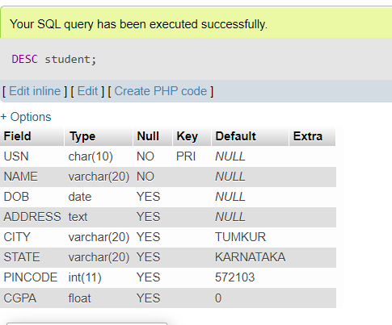

1. Insert above given data for student table.

**INSERT INTO student VALUES ('1SI23MBA01', 'AAA', '1995-01-01', 'B H ROAD', 'TUMKUR', 'KARNATAKA', 572103, 8.5);**

**INSERT INTO student VALUES ('1SI23MBA02', 'BBB', '1996-01-01', 'BANGALORE', 'BANGALORE', 'KARNATAKA', 560001, 9.5);**

**INSERT INTO student VALUES ('1SI23MBA03', 'CCC', '1997-01-01', 'B H ROAD', 'TUMKUR', 'KARNATAKA', 572103, 7.5);**

**INSERT INTO student VALUES ('1SI23MBA04', 'DDD', '1998-01-01', 'B H ROAD', 'TUMKUR', 'KARNATAKA', 572103, 8.5);**

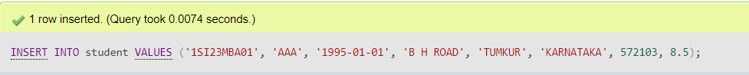

Like this way for each queries get executed.

Red highlighted records demonstrate Primary Key constraint, show error while inserting duplicate records.

**INSERT INTO student VALUES ('1SI23MBA04', 'DDD', '1998-01-01', 'B H ROAD', 'TUMKUR', 'KARNATAKA', 572103, 8.5);**

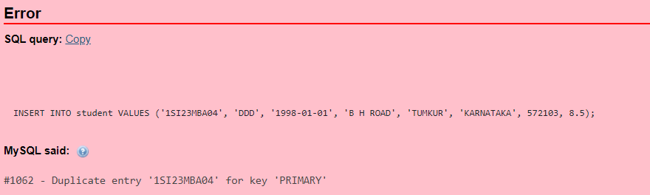

Blue highlighted records (1SI23MBA05) demonstrate NOT NULL constraint on Name column.

**INSERT INTO student VALUES ('1SI23MBA05', Null, '1999-01-01', 'B H ROAD', 'TUMKUR', 'KARNATAKA', 572103, 8.5);**

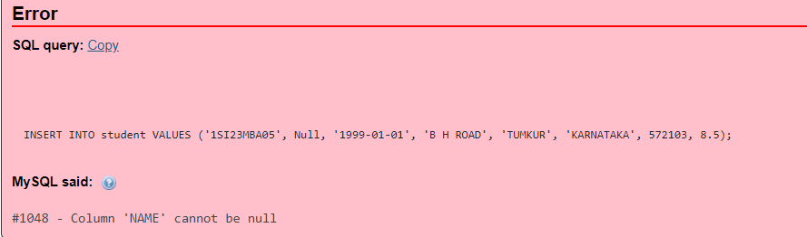

Green highlighted records (1SI23MBA06) demonstrate DEFAULT constraint on CITY, STATE, PINCODE column

**INSERT INTO student (USN, NAME, DOB, ADDRESS) VALUES ('1SI23MBA06', 'FFF', '1999-01-01', 'B H ROAD');**

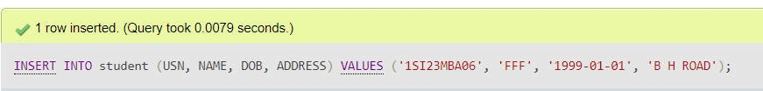

Click on student table on left panel, will display table data.

Last records having default values for the columns where DEFAULT constraint applied.

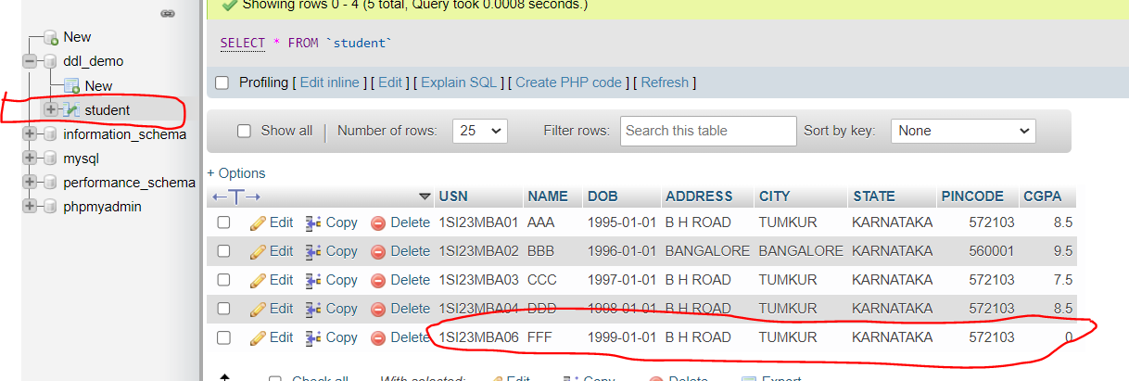

1. Execute the TRUNCATE command to delete all the records from student table

**TRUNCATE TABLE student;**

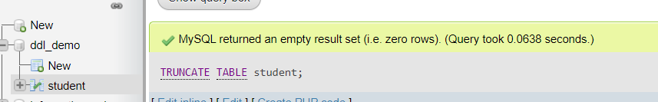

Click on student table on left panel, will display table data, since we have executed TRUNCATE command table is empty now.

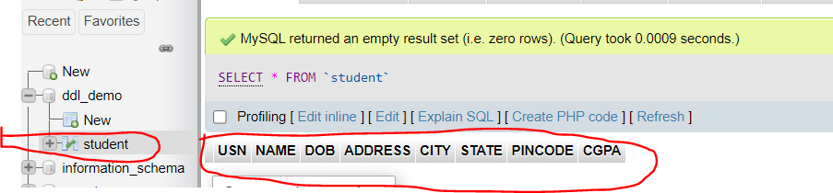

1. Drop student table from **ddl_demo** database.

**DROP TABLE student;**

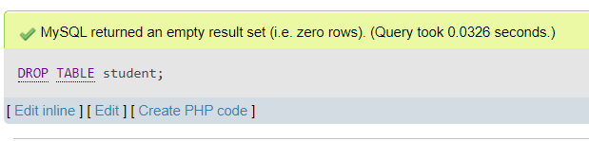

1. List all the tables after dropping student table.

**SHOW TABLES;**



Since we have deleted the student table, there are no tables in ddl_demo database.

1. Drop **ddl_demo** database from MySQL.

**DROP DATABASE ddl_demo;**

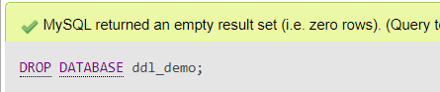

1. List all the database after dropping **ddl_demo** command.

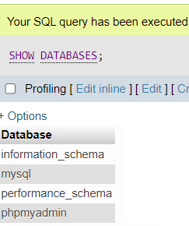

ddl_demo is also deleted, and not available in database list.